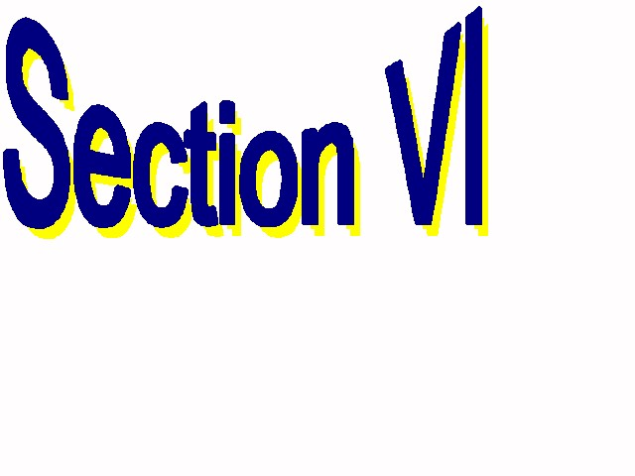
355 Harlem Rd.
West Seneca, NY 14224
(716) 821-7092 (716) 821-7299 FAX: (716) 821-7352
tslade@e1b.org cszczesny@e1b.org website: www.section6.e1b.org

Proposal/Contract between Section VI and a Sports Facility

This proposal, which becomes a contract when signed by both parties, details the arrangement between Section VI of the New York State Public High School Athletic Association and the venue listed, for usage of specific sports facilities at that venue. Section VI will provide a Certificate of General Liability Insurance for the event(s).

Venue:
Address:
Venue Coordinator: Phone:
Sporting Event:
Date(s)/ Time (s):
Facility to be used: (gym, pool, track, etc.)
Rent/ Usage fee:
Other Fees (if any): Item Charge

Venue Coordinator Signature:
Date

Section VI Sportchair responsible for contest management:
Name: Phone:

Approved By Section VI Office Personnel:
Name Title

Signature:
Date
Revised 1/25/10
35

